IS:240 PROJECT 3

Name: _______________

Log on to Oracle SQL Developer using the account provided by your instructor. Query the HR sample database schema and answer the following questions.

  - Write a query to find the highest, lowest, sum, and average salary of all employees. Label the column as Maximum, Minimum, Sum, and Average, respectively. Round your results to the nearest whole number.
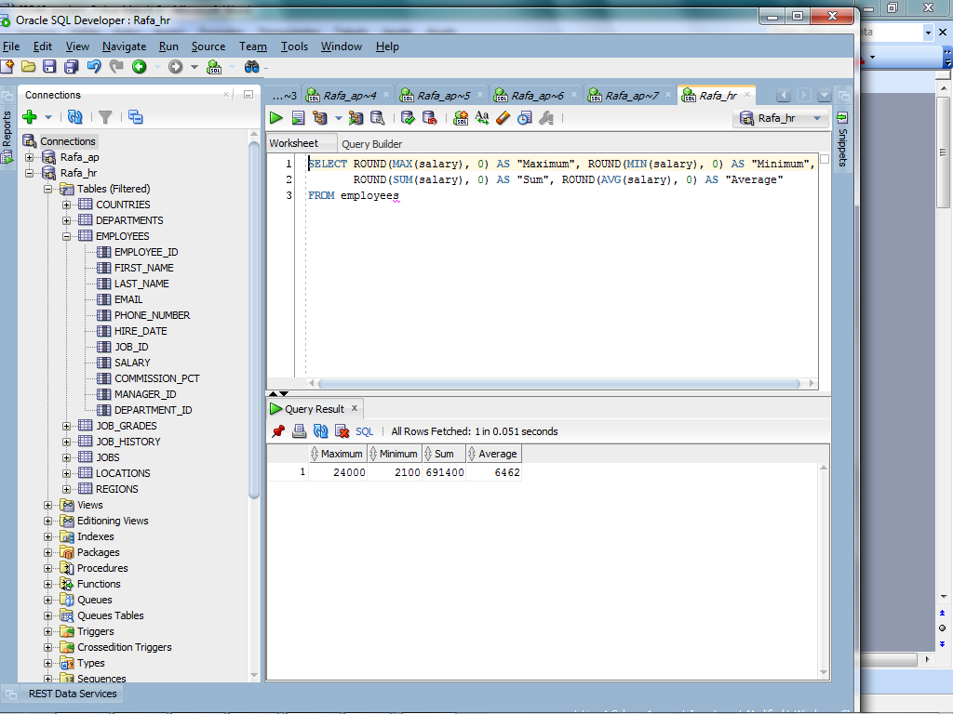

  - Modify the previous query to display the minimum, maximum, sum, and average salary for each job type.

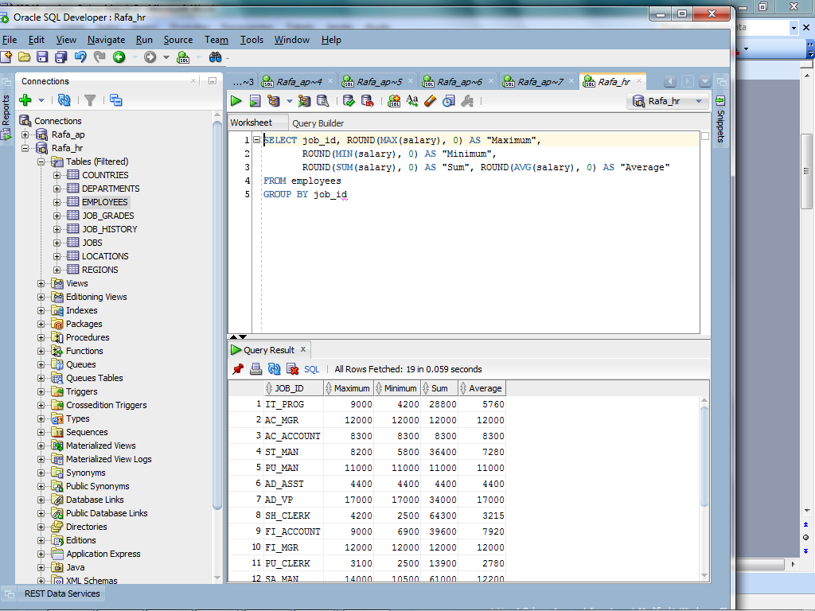

  - Write a query to display the number of people with the same job.
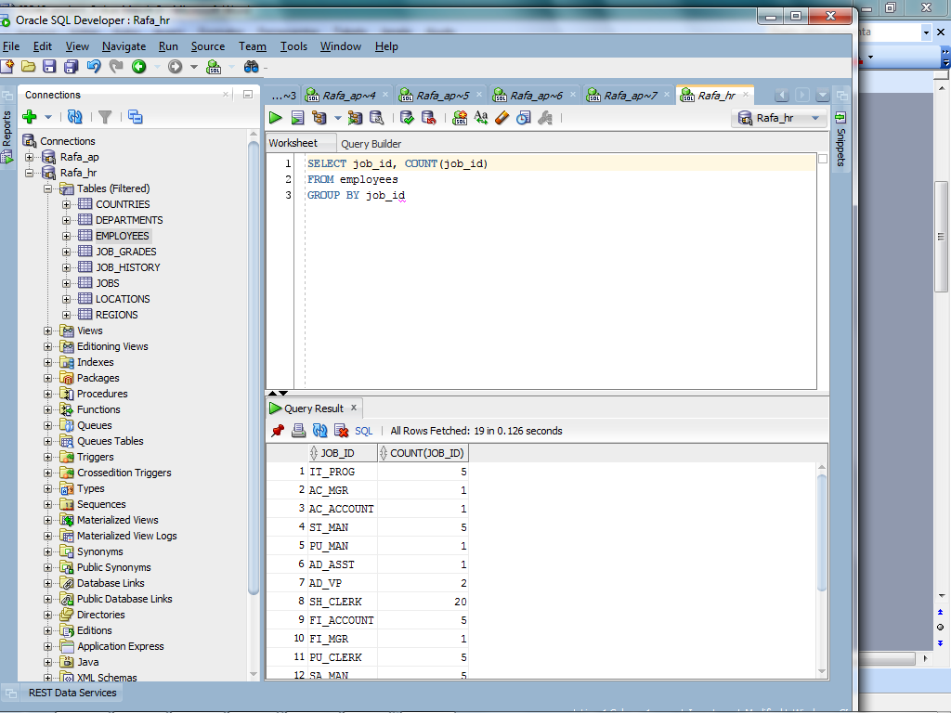
  - Determine the number of managers without listing them. Label the column as Number of Managers. Hint: Use the MANAGER_ID column to determine the number of managers.

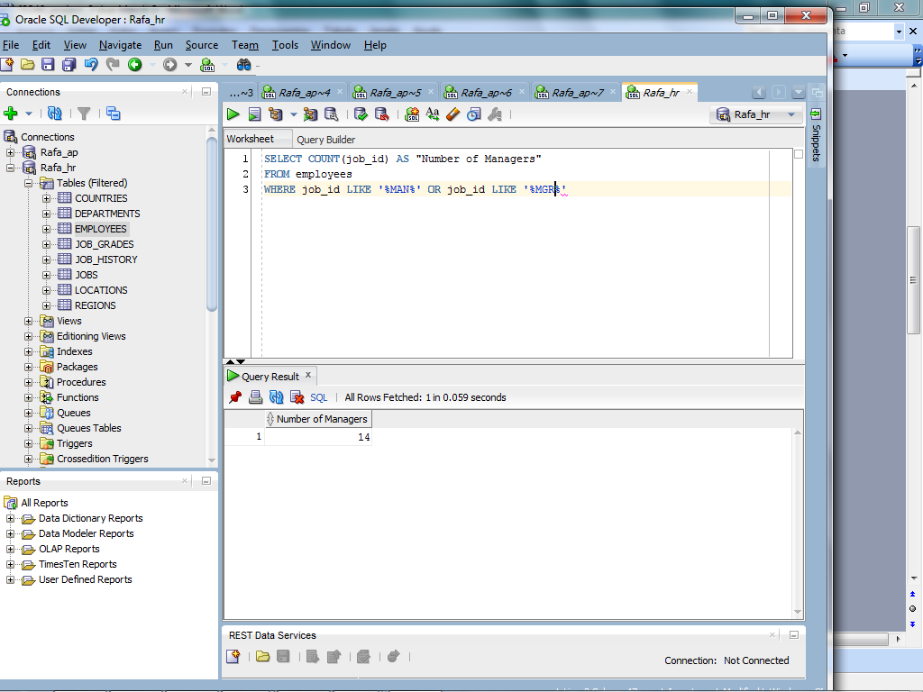

  - Create a query to display the total number of employees and, of that total, the number of employees hired in 1995, 1996, 1997, and 1998. Create appropriate column headings.
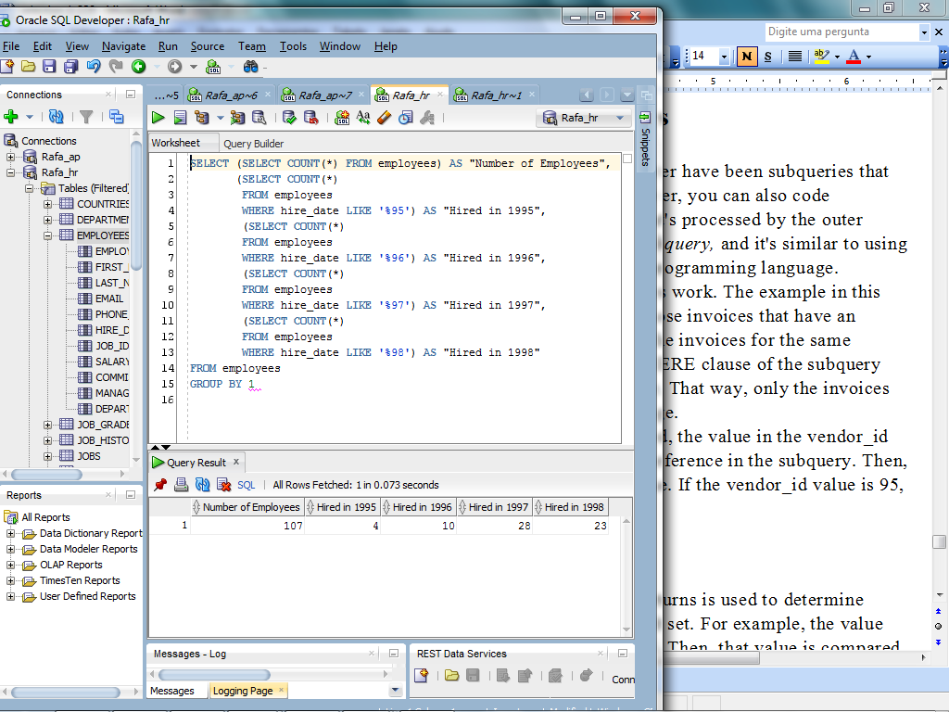
  - The HR department needs a report of employees in Toronto. Display the last name, job, department number, and the department name for all employees who work in Toronto.

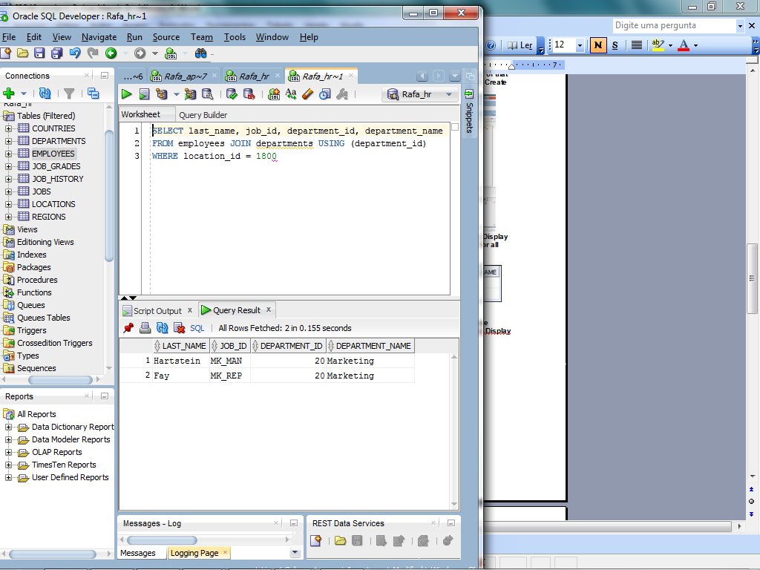

  - Create a report to display employees’ last name and employee number along with their manager’s last name and manager number.Display all employees including King, who has no manager.
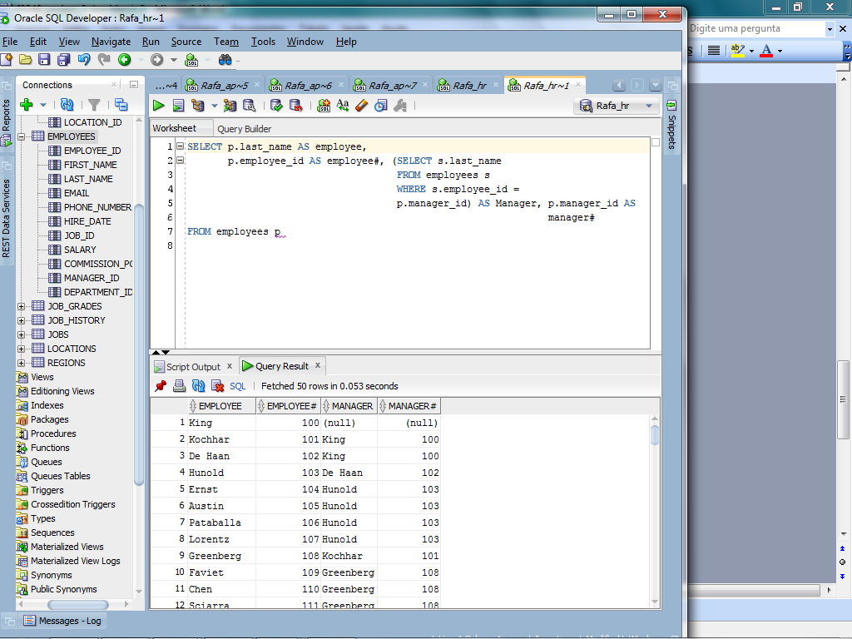
  - The HR department needs a report on job grades and salaries. Create a query that displays the name, job, department name, salary, and grade for all employees.
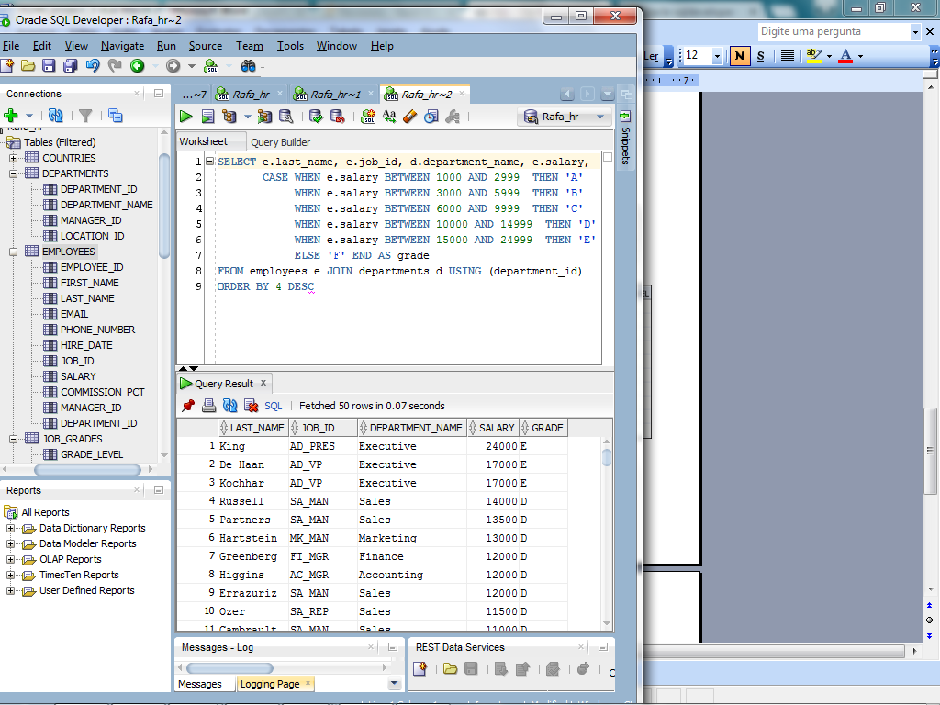
  - The HR department wants to determine the names of all the employees who were hired after employee Davies. Create a query to display the name and hire date of any employee hired after Davies.
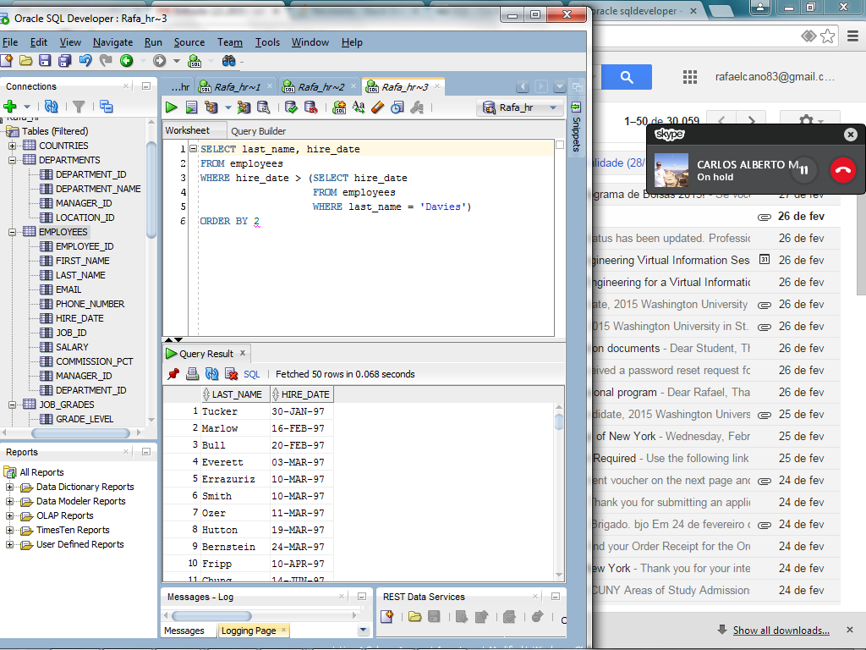
  - The HR department needs to find the names and hire dates of all the employees who were hired before their managers, along with their managers’ names and hire dates.
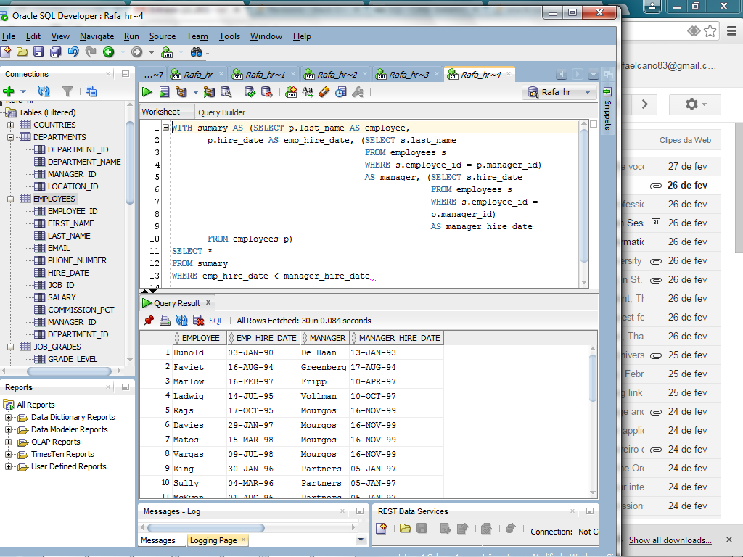
Take a screen shot of each query and its output screen(s) and paste them to your answer sheet.

